

**NEXUS SERVICE MARKETING SYSTEM**

|  |  |  |
| --- | --- | --- |
| **Supervisor:** | *LÊ THANH NHÂN* | |
| **Semester:** | *III* | |
| **Batch No:** | *T1.2208.M2* | |
| **Group No:** | *03* | |
| **Order:** | **Full name** | **Roll No.** |
| *1.* | *TRẦN THIỆN HIẾU* | Student1394598 |
| *2.* | *TRẦN VĂN PHÁT* | Student1398823 |
| *3.* | *NGUYỄN VĂN THIỆN* | Student1408856 |

***Month****:1* ***Year****:2023*

**USER GUIDE**

**I.User**

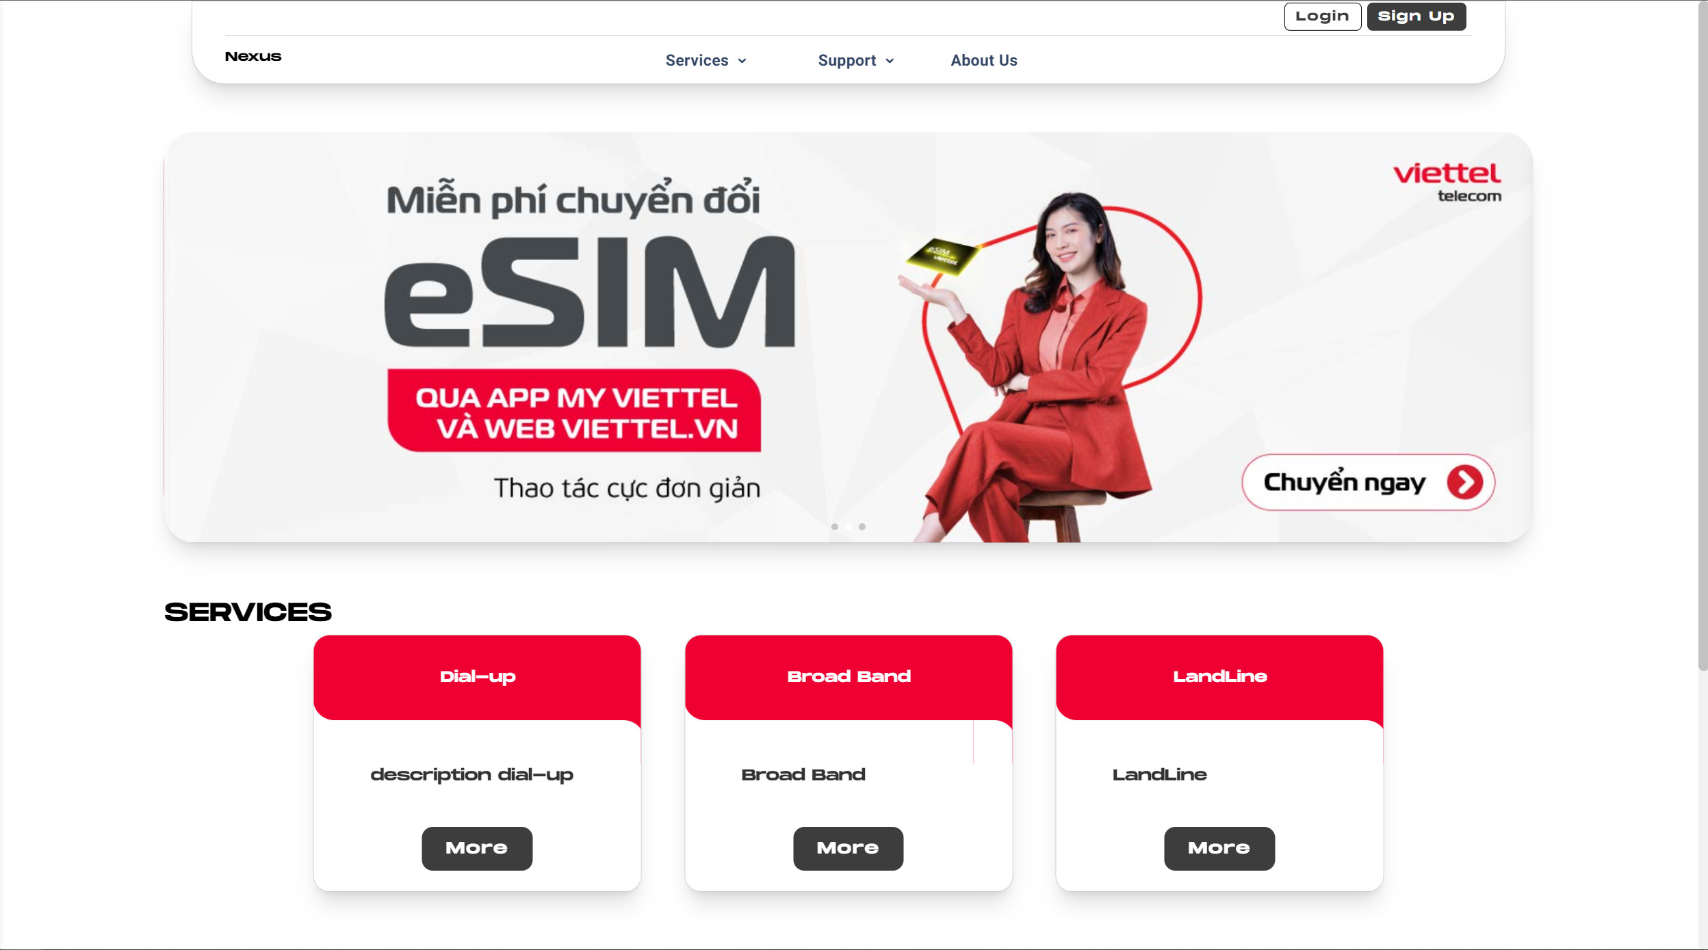

**1. Sign Up**

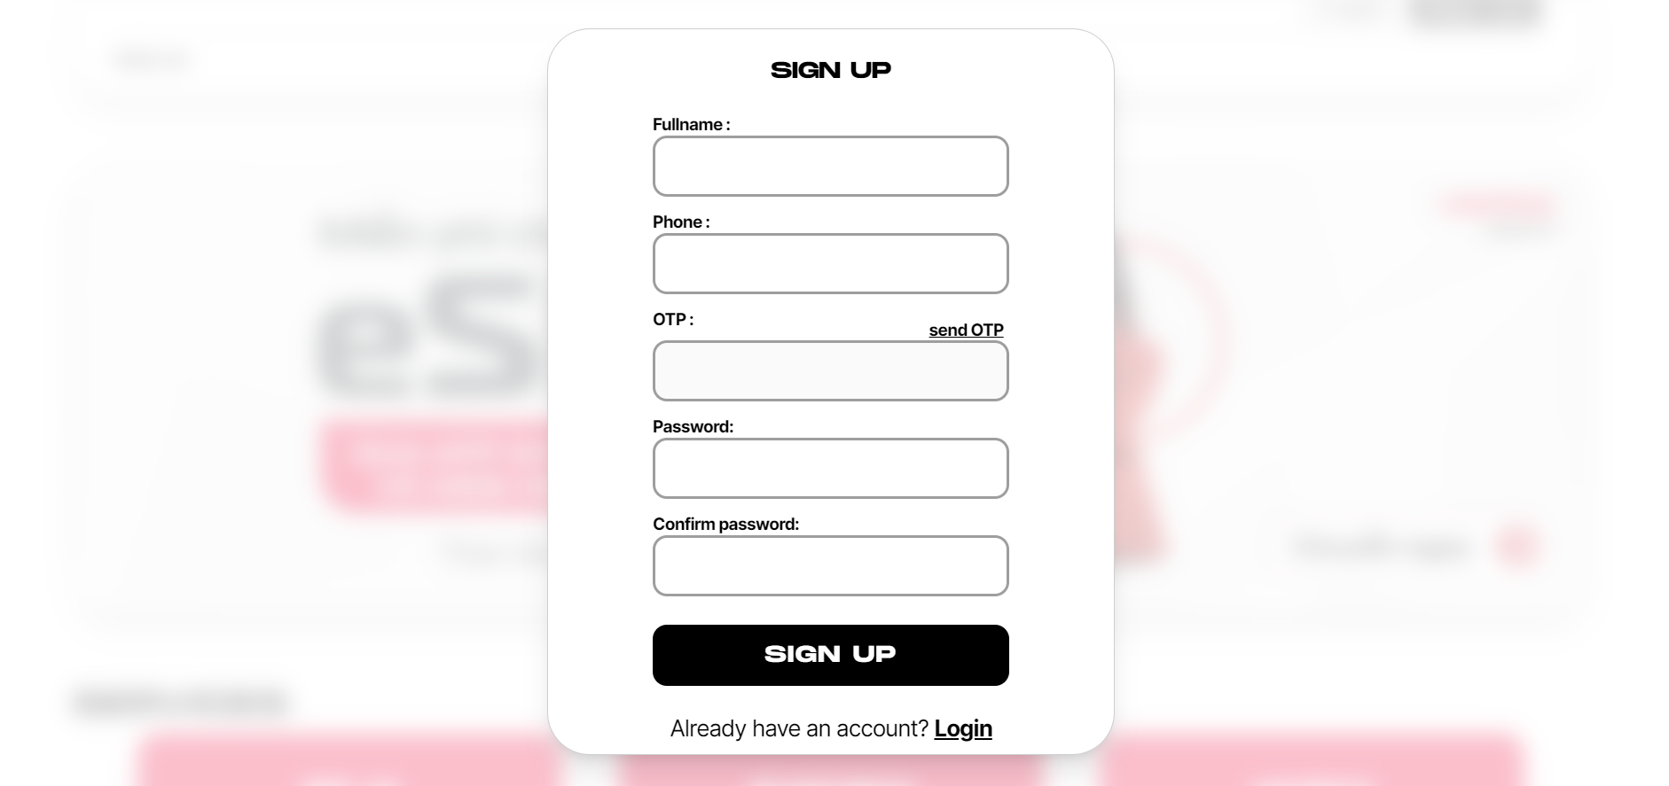

- When you click sign up, an account registration form will appear, then please register.

**2. Login**

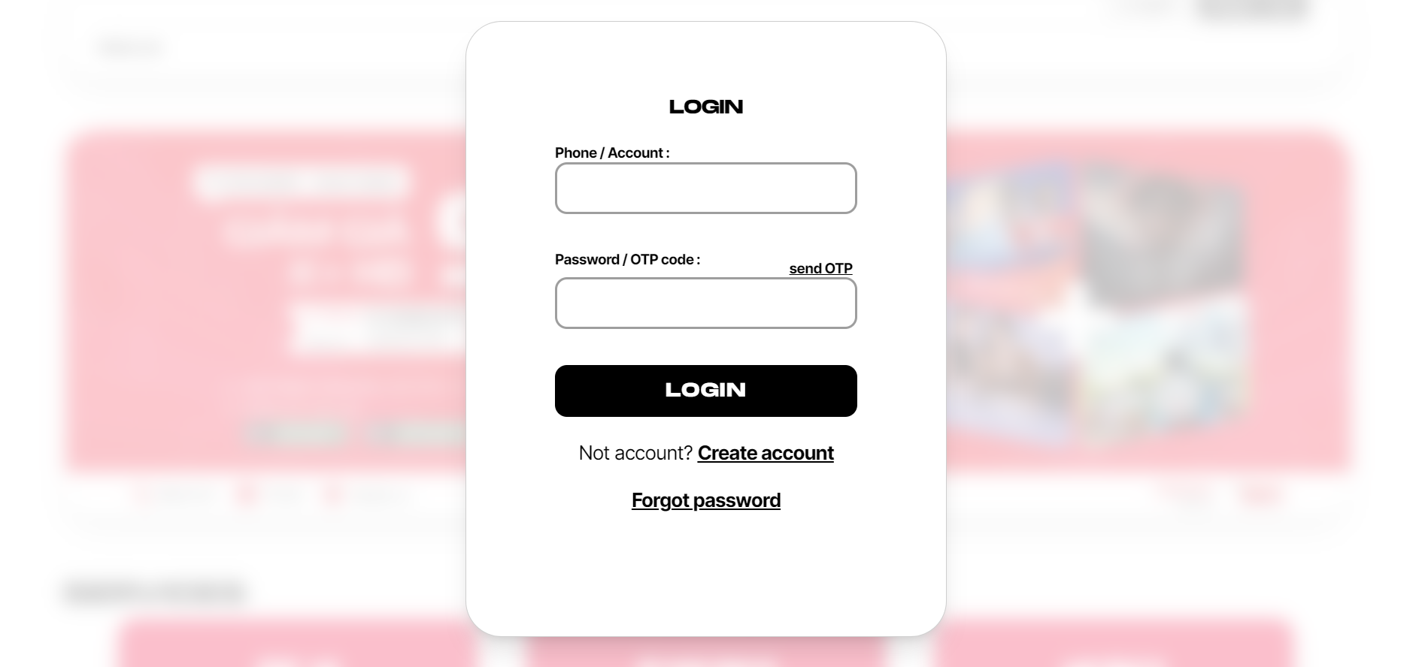

**-** If you already have an account, please click this button to log in to the system.

**3. Service**

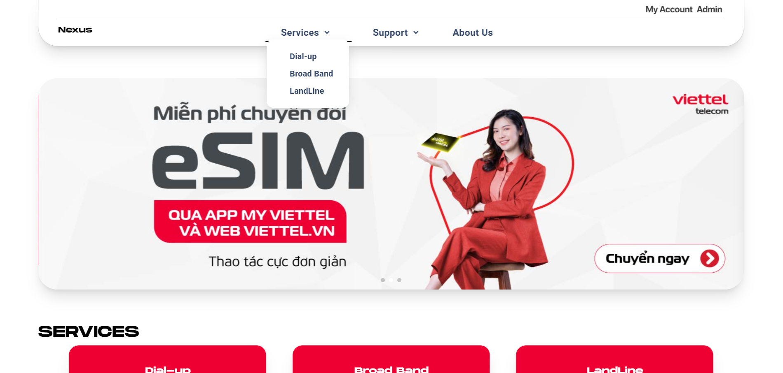

**-** When you place the mouse cursor on "Service", 3 types of services that we are currently providing will appear: "Dial Up, Boardband, Landline".

**4. Dial Up, Boardband, Landline**

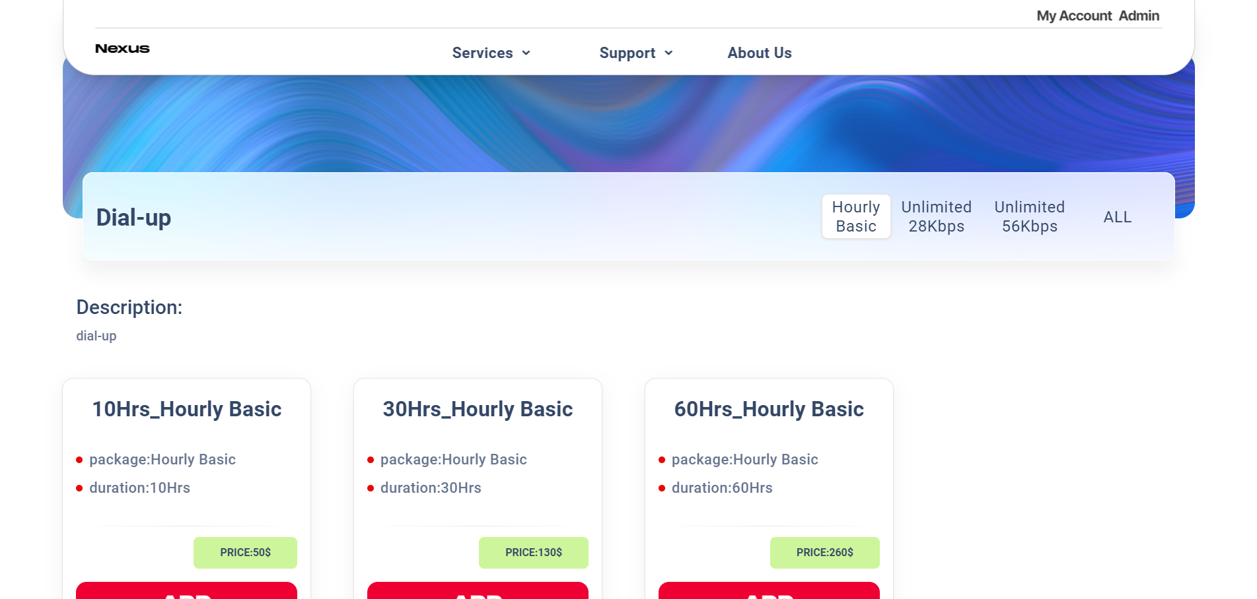

**-** When you click on one of the above service types, all registration packages corresponding to each service will appear. You can then refer to and register for our service.

**5. Supports**

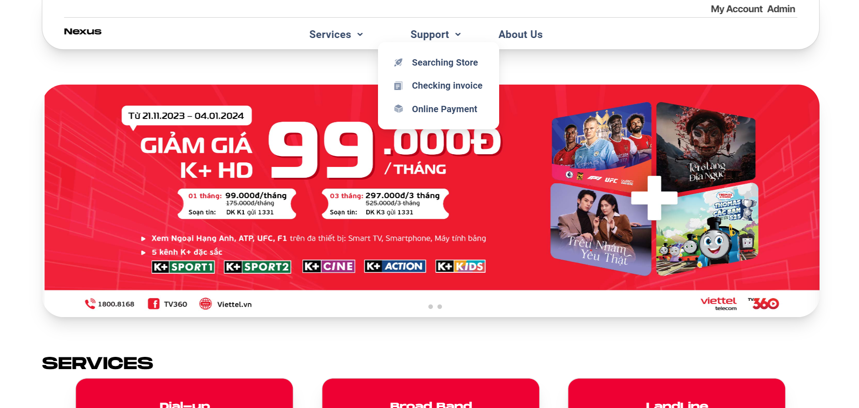

**-** When you place the mouse cursor on "Support", 3 types of support will appear: "Searching Store, Checking invoice, Online payment".

**6. Searching Store, Checking invoice, Online payment**

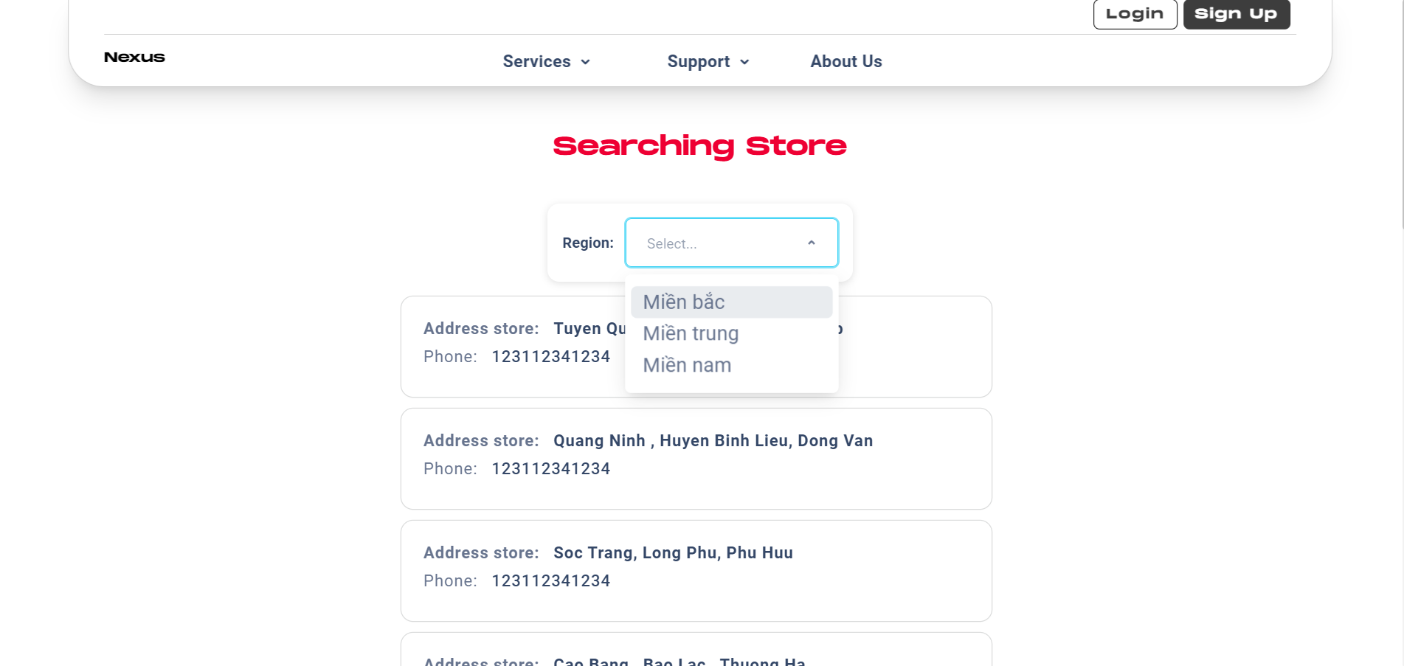

**-** When you click on "Searching store", it will move to the search page for stores divided into 3 regions: north, central, and south.

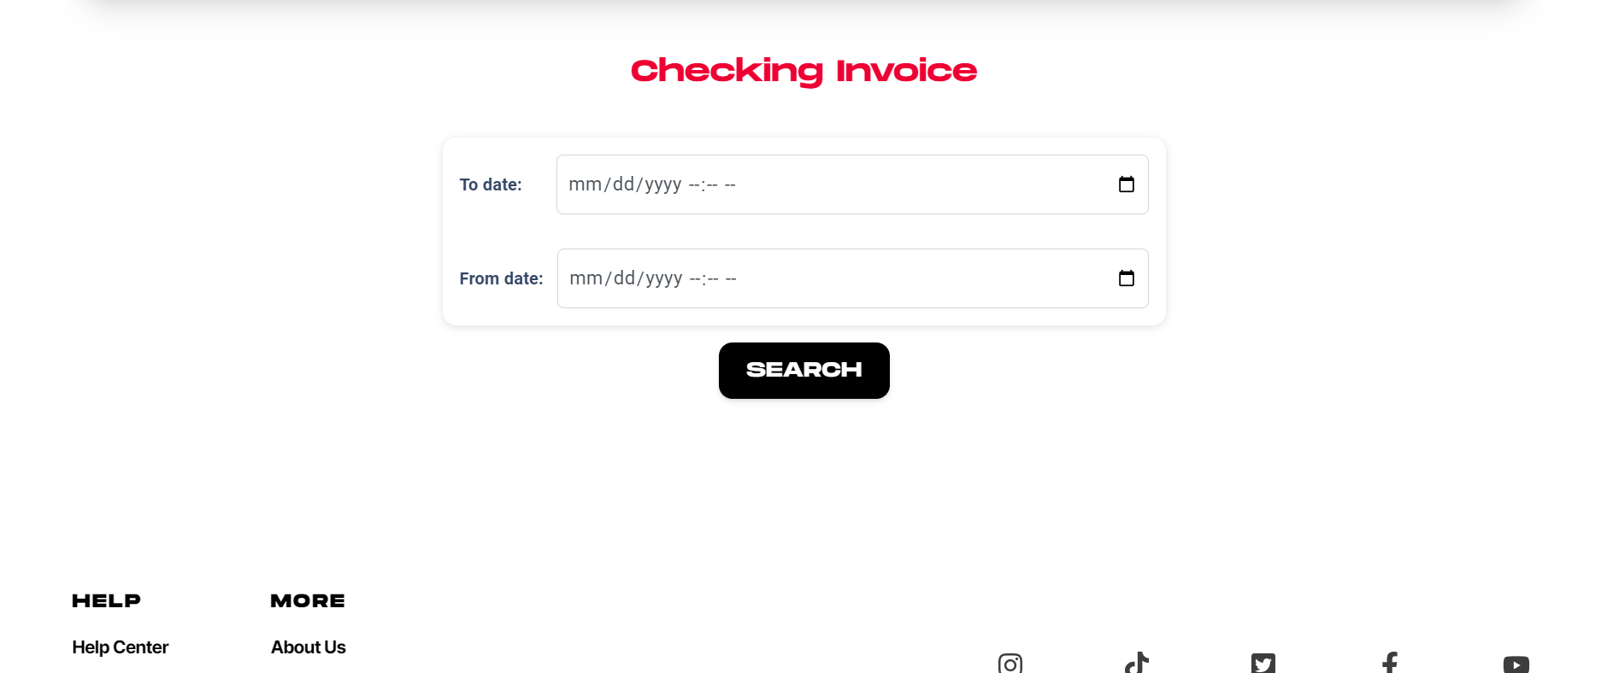

**-** When you click on "Checking invoice" it will move to the invoice search page, you will enter the period from this date to the last date you want to search and press the "Search" button.

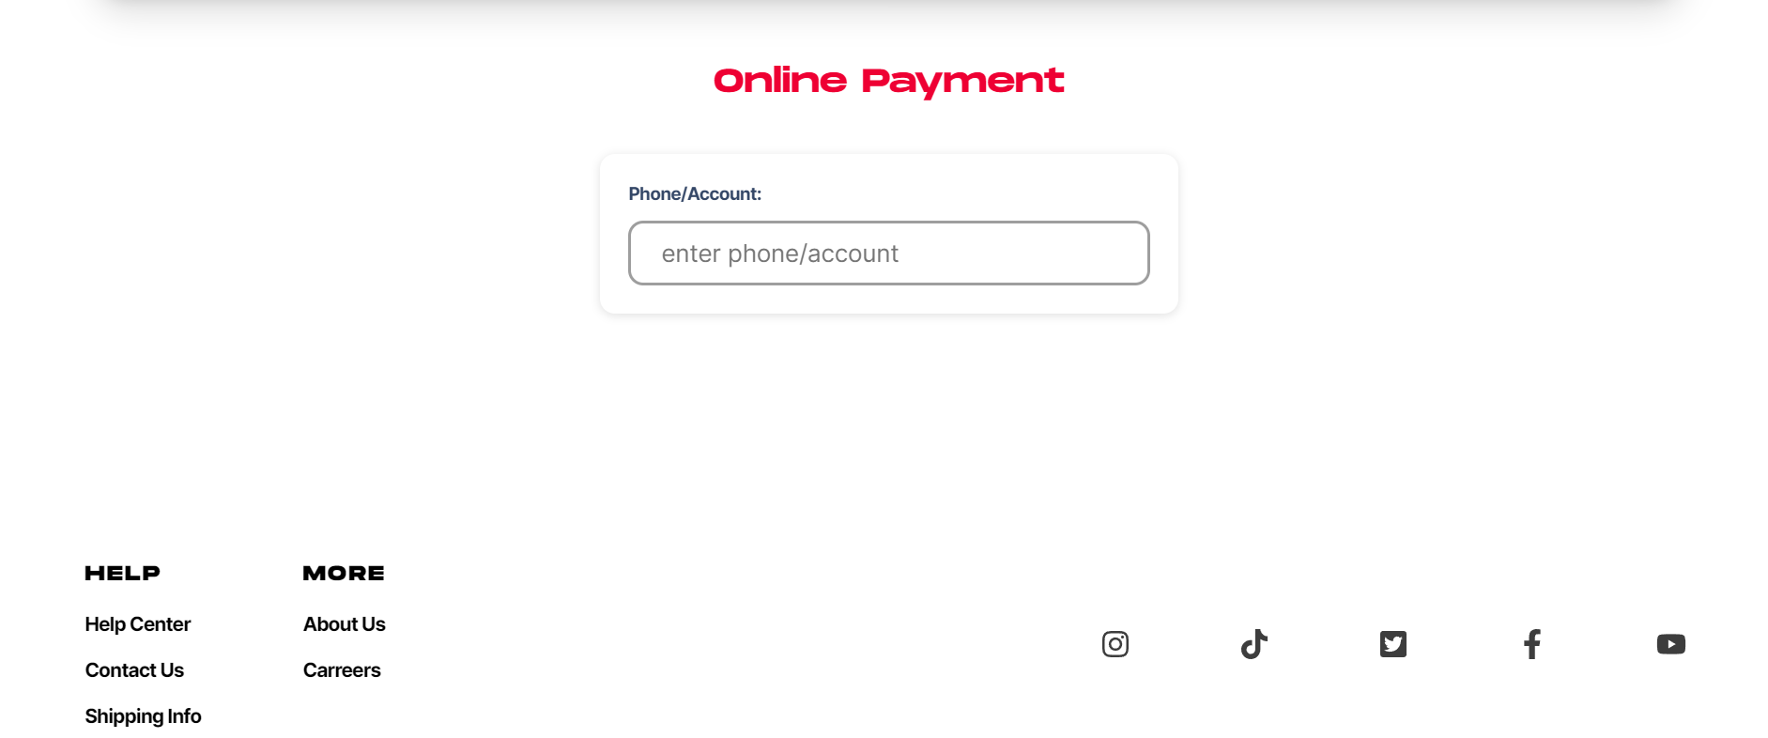

**-** When you click on "Online payment" it will move to the payment page, then you will enter your phone number and pay according to the package you have signed up for.

**7. About Us**

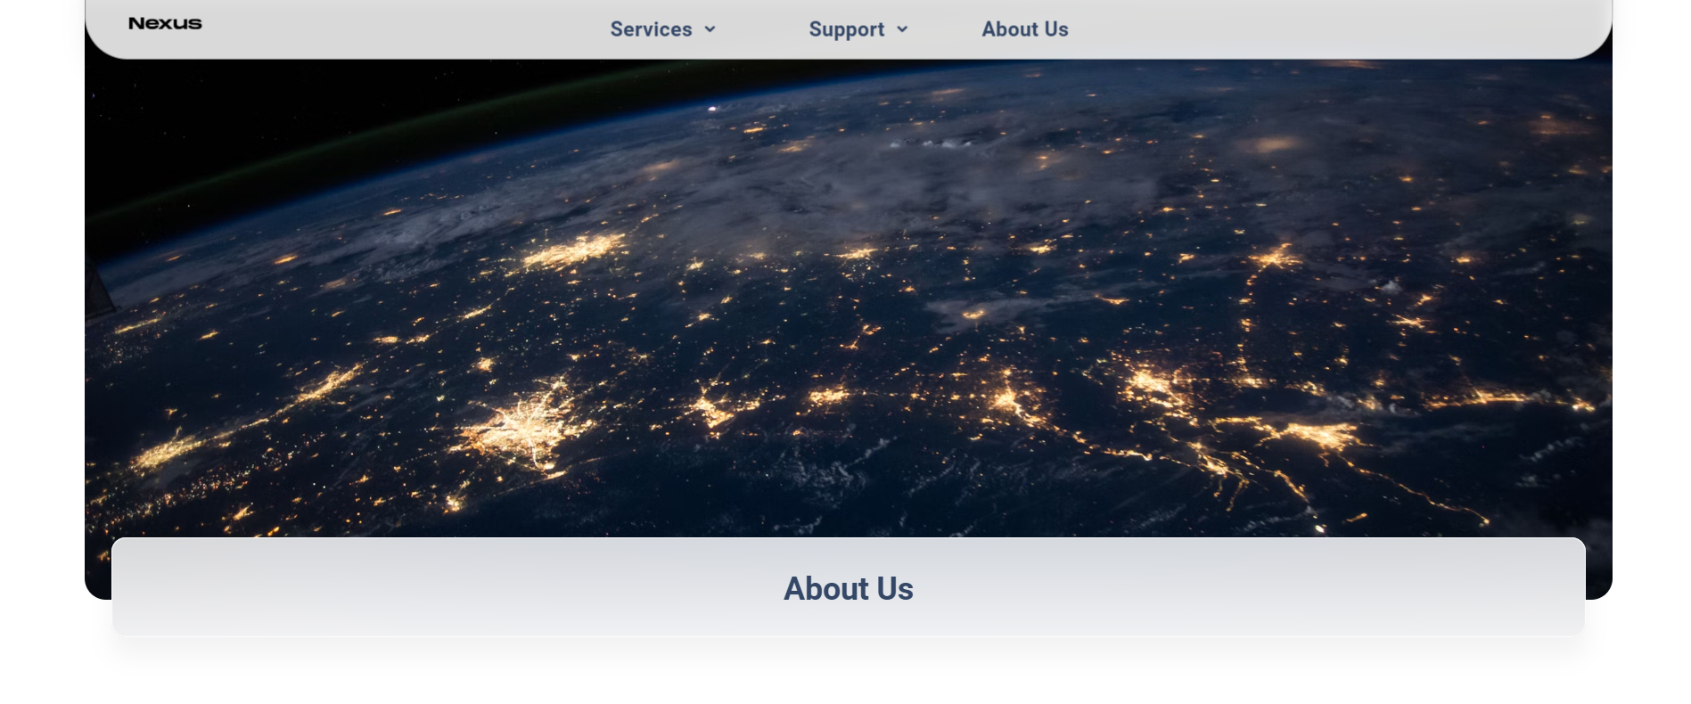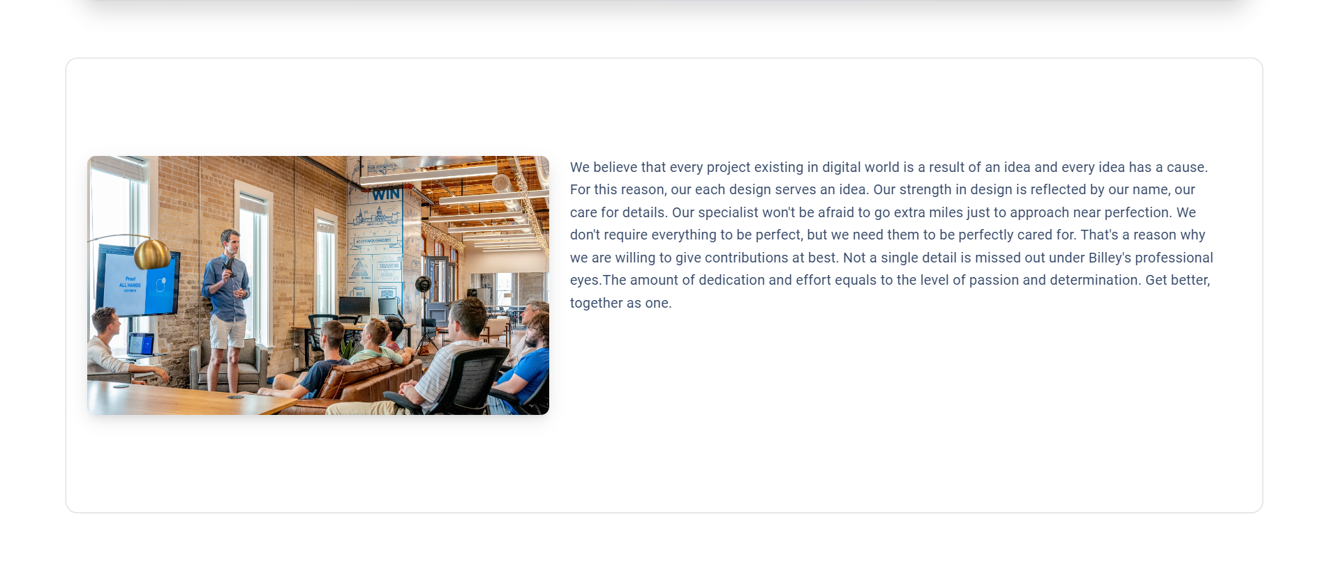

**-** Click on "About Us" to go to the about us page

**II. Admin**

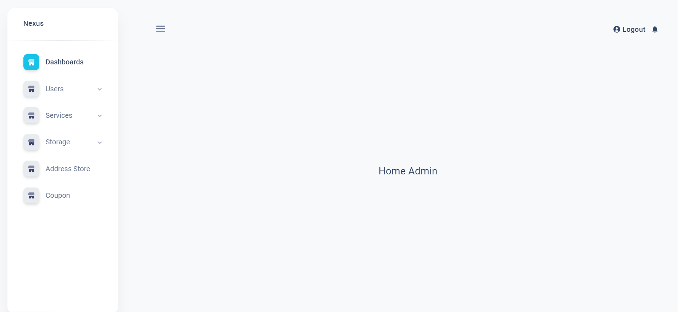

Next is the admin section.

**1. Users**

- When clicking on "Users", two sections will appear: "customer" and "employee".

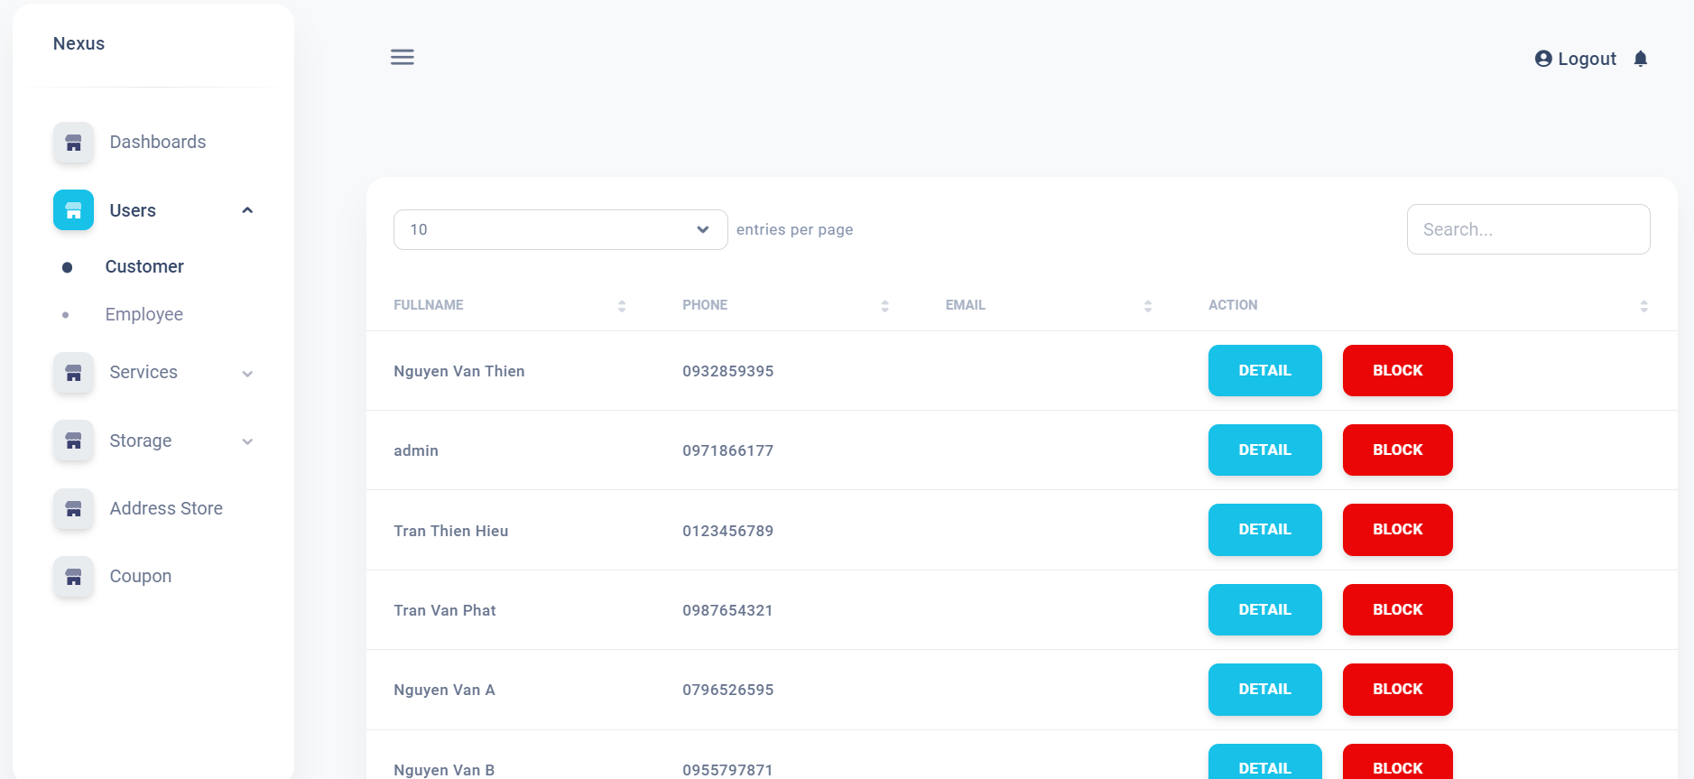

- Click on "customer" and a list of customers will appear. we can manage them by admin.

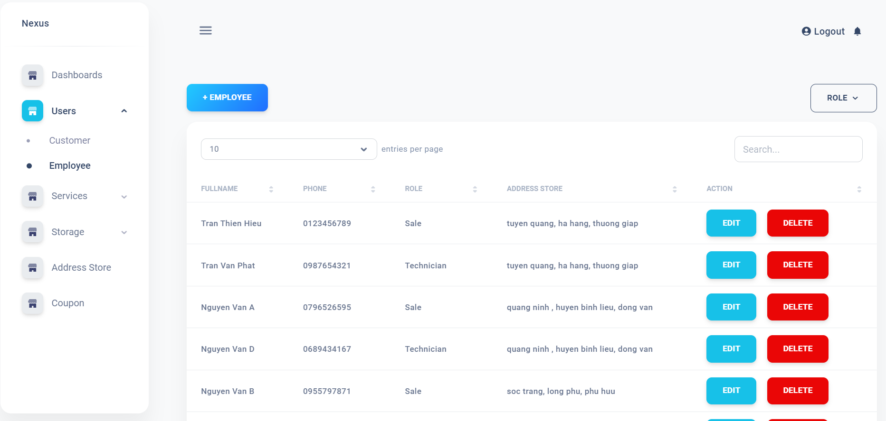

**-** Click on "Employee" and a list of employees will appear, excluding customers. we can manage them

**2. Service**

**-** When clicking on "Service", two sections will appear: "Connect type" and "Package".

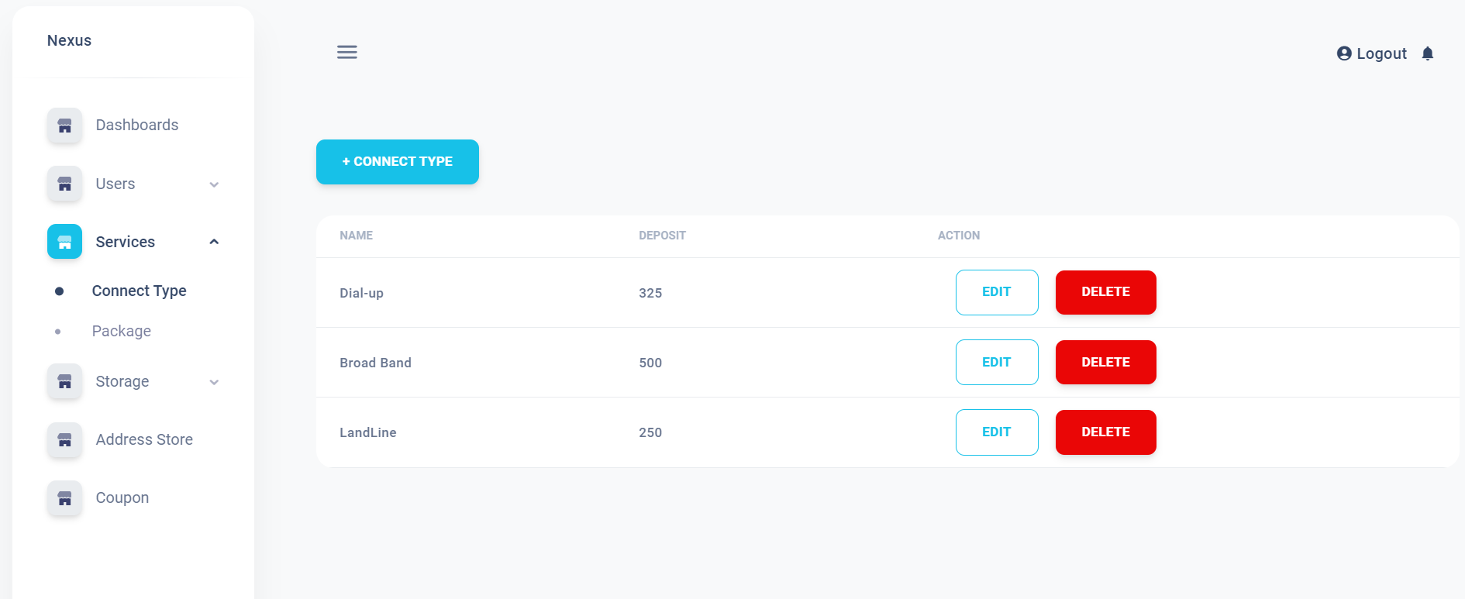

- Click on "Connect Type" and a list of customers will appear. we can manage them by admin.

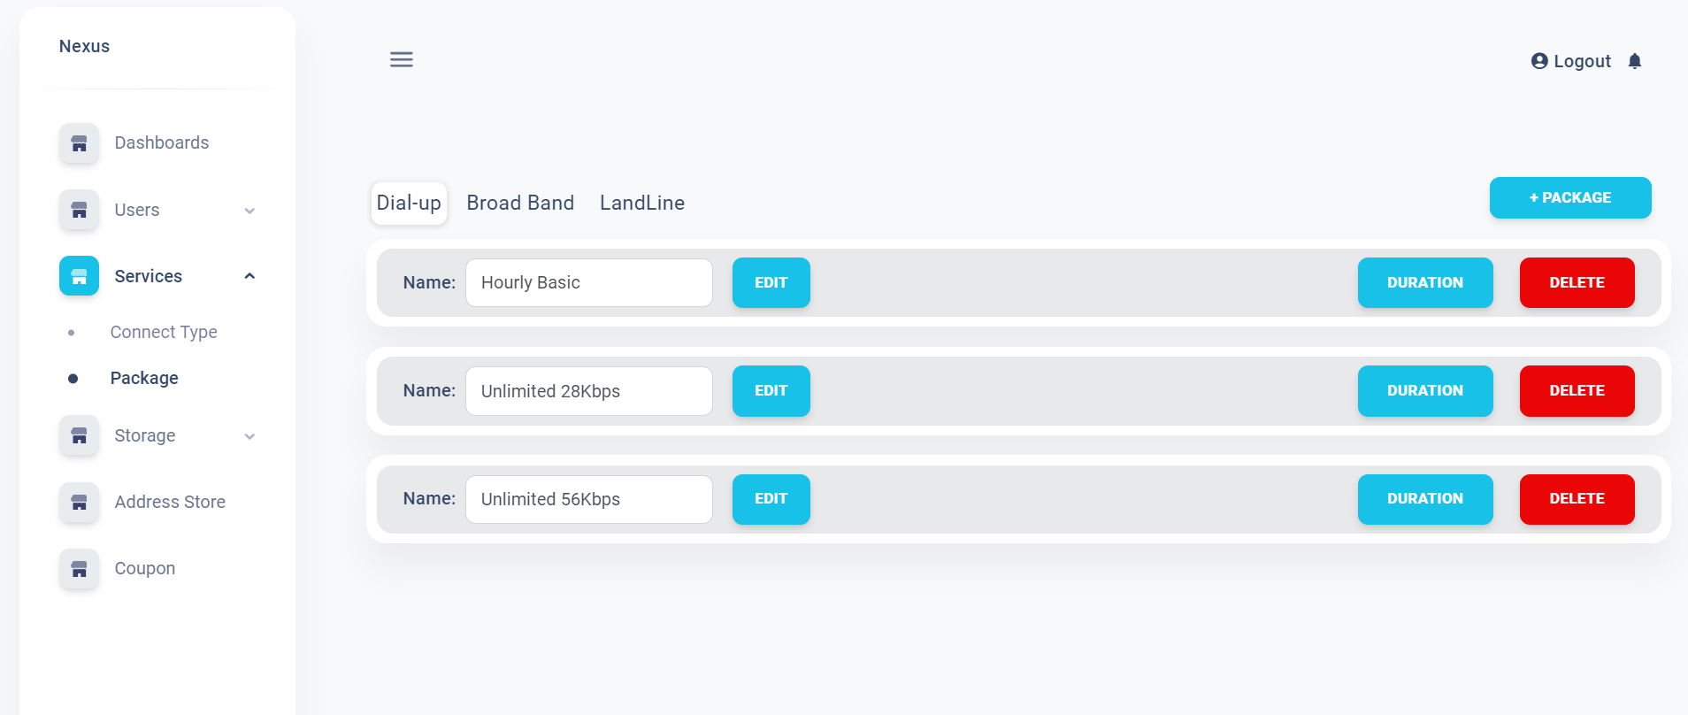

- Click on "Package" and a list of packages will appear and they can be managed by the admin

**3. Storage**

**-** When clicking on "Storage", two sections will appear: "Products" and "Suppliers".

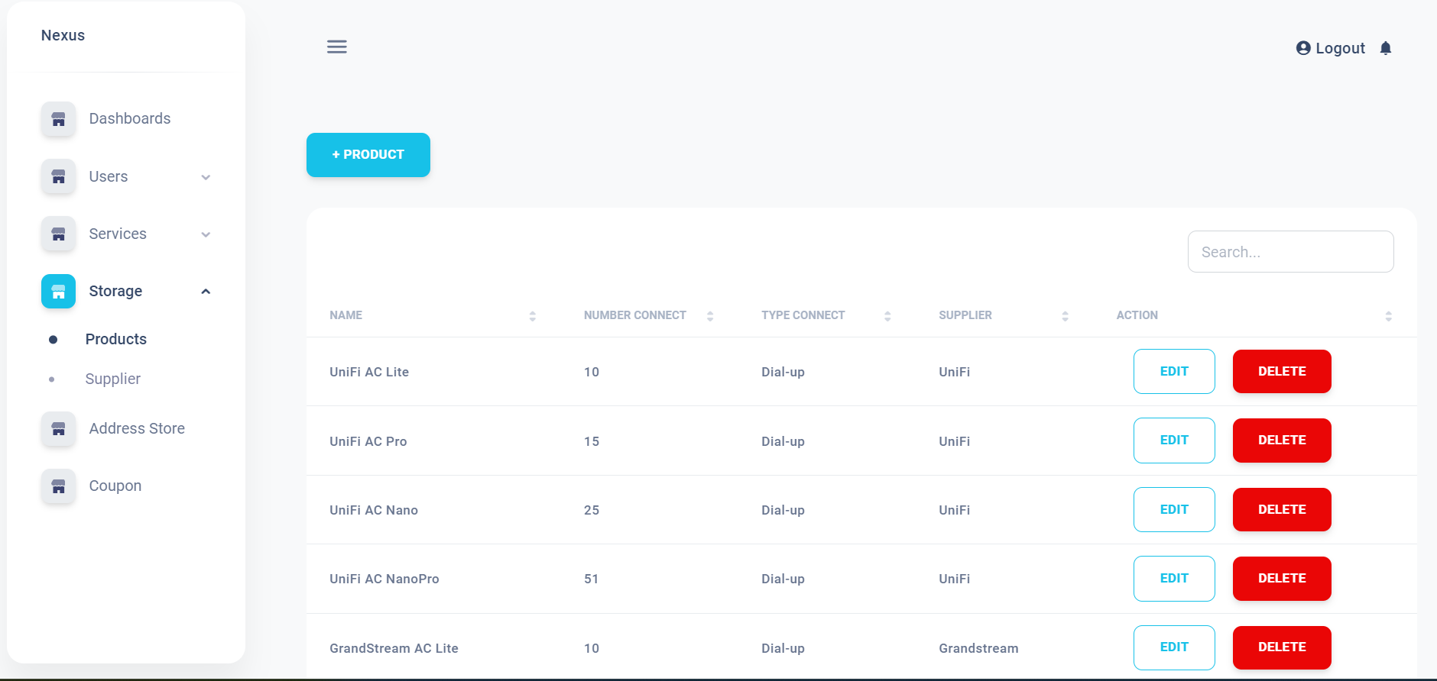

- Click on "Product" and a list of product will appear. we can manage them by admin.

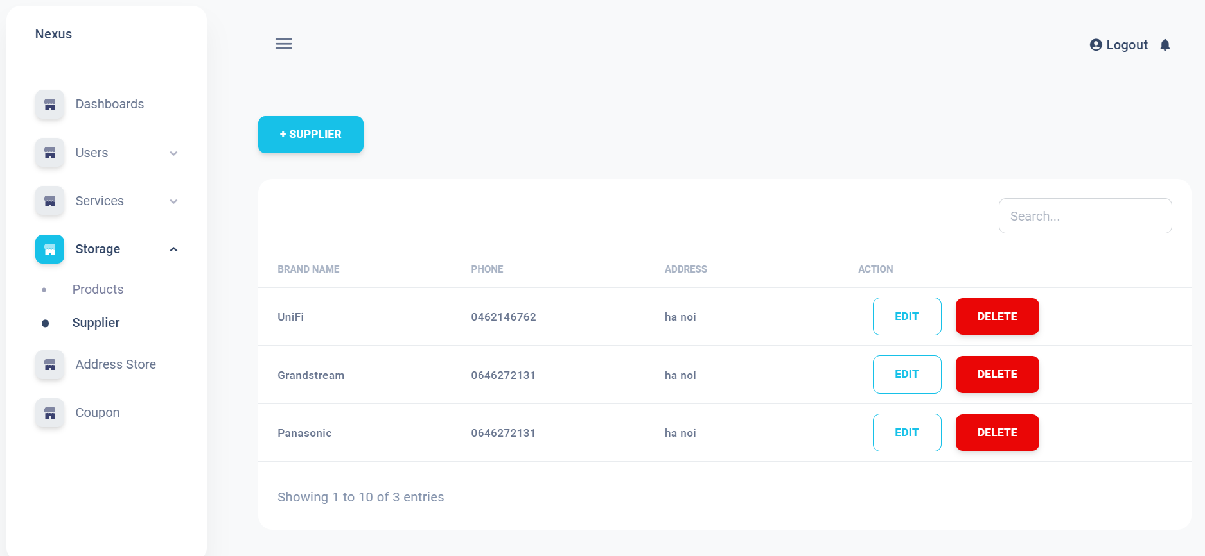

- Click on "Suppliers" and a list of product suppliers will appear and is managed by the admin

**4. Address Store**

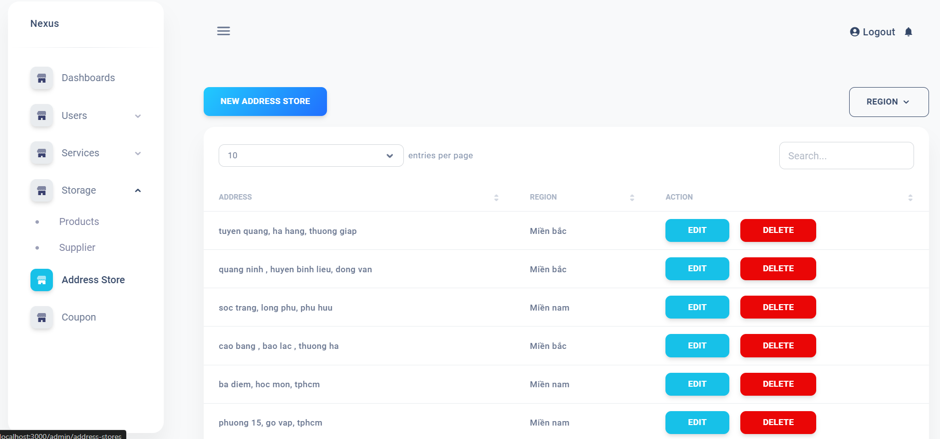

- Clicking on "address Store" will display a list of the company's retail stores, and are managed by the admin.

**5. Coupon**

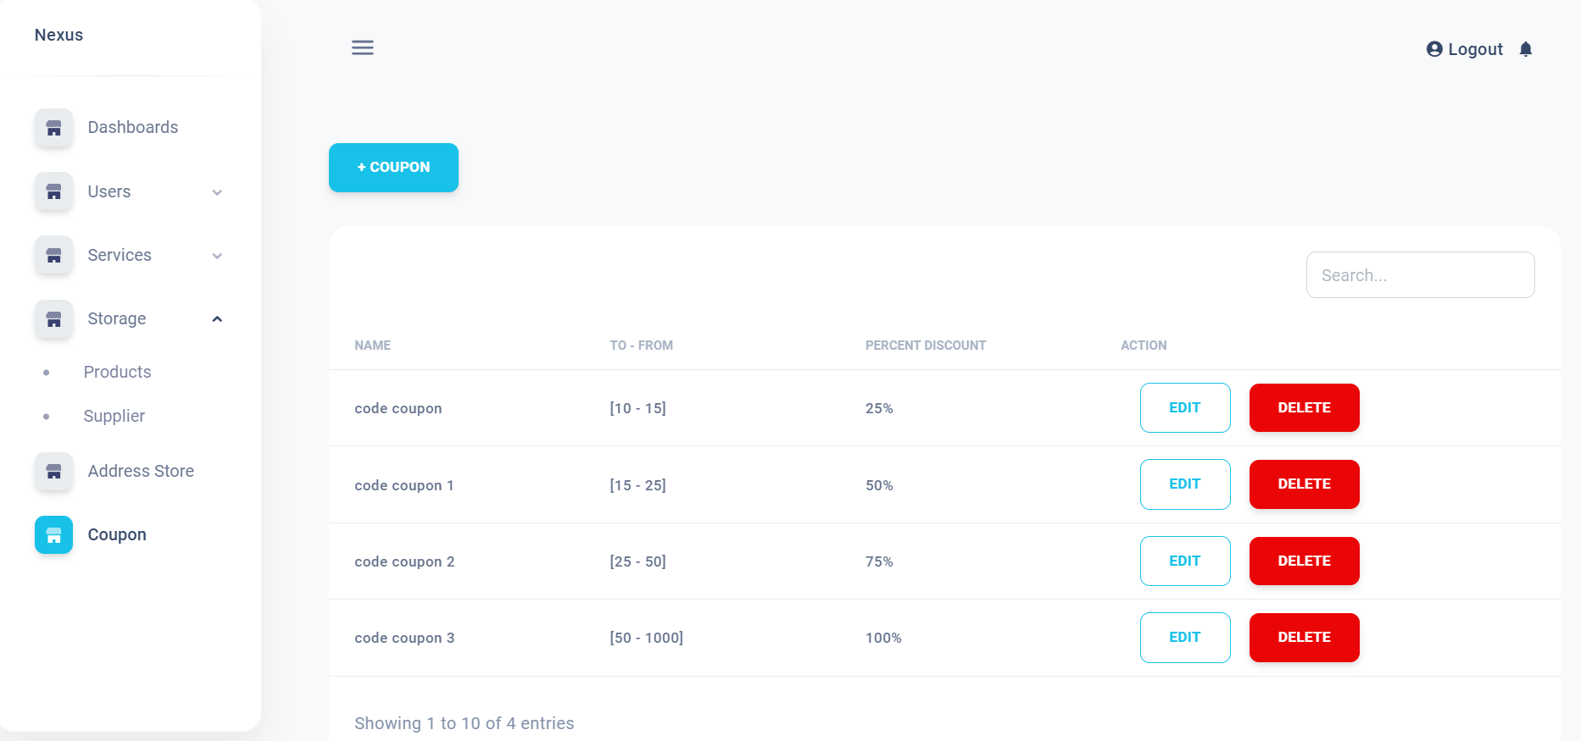

- Clicking on "coupon" will display a list of discount codes ranging from 25% to 100% depending on the number of user connections and will be reduced in the deposit, which will be managed by the admin.